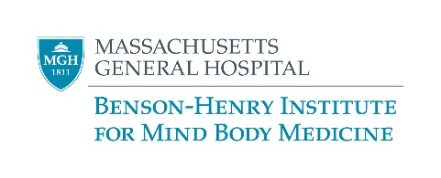

Virtual Stress Management and Resiliency Training (SMART) EXAMPLE SYLLABUS

Session | Date | Agenda
Session 1: | Wednesday, Oct 14, 2020  1:00-2:30 | Overview of mind body research and practices  Energy Battery  Breath & Body Awareness
Session 2: | Wednesday, Oct 21, 2020  1:00-2:30 | Mini Meditations  Sleep Hygiene  Body Scan
Session 3: | Wednesday, Oct 28, 2020  1:00-2:30 | Social Support  Stress warning signals  Mindfulness Components
Session 4: | Wednesday, Nov 4, 2020  1:00-2:30 | Pleasant Behaviors  & Self-Care Goal setting  Chair Yoga  Intro to thought distortions & how to combat them  “New & Good”
Session 5: | Wednesday, Nov 18, 2020  1:00-2:30 | Insight Imagery-“Safe Space” Meditation  Good, Bad, Routine exercise  Adaptive Perspectives  Problem-Solving vs Acceptance During Stress  Stop Breathe Reflect Choose
Session 6: | Wednesday, Dec 2, 2020  1:00-2:30 | Healthy Diet & Super foods  Mindful Eating  Contemplation Meditation  Achieving Optimism  Relaxation Signals
Session 7: | Wednesday, Dec 9, 2020  1:00-2:30 | Lovingkindness Meditation  Physical Activity  Root Fear  Creative Expression  Perception/Mindsets
Session 8: | Wednesday, Dec 16, 2020  1:00-2:30 | Empathy/Self Compassion  Humor & Health Benefits  Staying resilient  Review of program  Letter to Self

